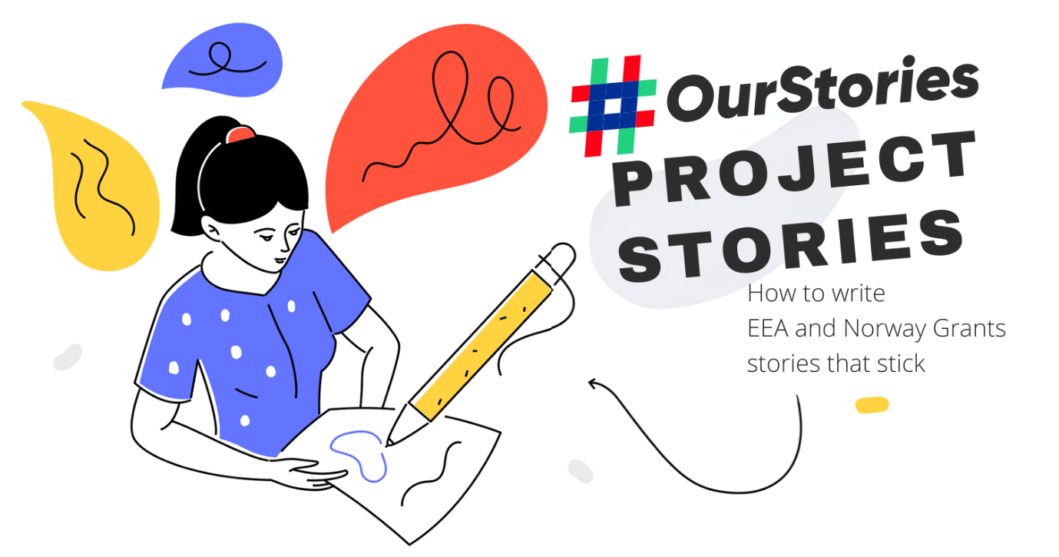
1/ HEADLINE
Your masterpiece won’t get any attention if your headline is bland and boring. 80% of readers never make it past the headline – think about that. The headline is the most important element of your content. No matter how good your article is, if your headline doesn’t hit the mark, no one will read it. Always assume your audience isn’t interested.
Tip: Make it catchy, on topic, and crystal clear. (PLAN B: test different headlines over time)
Combine it with a picture that catches the eye and screams to be clicked on.
Length: keep it short & punchy (max 80 characters)

2/ LEAD
Max 80 words

Example: There are 9 500 kilometres between Greece and the Paralympics in Japan. That represents a 13-hour flight – and most often – a lifetime of training, commitment and sheer willpower for professional athletes. First-ever female competitor to be part of the Refugee Paralympic Team, Alia Issa, talks about her inspiring journey from Athens to the Tokyo 2020 Paralympic Games, made possible by RePower - a project funded by the EEA and Norway Grants.

The lead, or opening paragraph, is the most important part of your story. Its mission is to catch the readers' attention and draw them in. It gives readers the most important information in a clear, concise and interesting manner. It also establishes the voice and direction of an article.

- Try to answer the #5W1H: who, what, when, where, why, how
- Create a conflict that you will solve in the article
- Make it audience focused and simple
- How is this story relevant to the Grants? Why now? Why are we sharing this?

Tip: Try to keep it focused – reading your lead should give a crystal-clear idea of what the rest of the article will explain. Make it resonate with your headline – and don’t shy away from a little bit of cliffhanging.
Length: ideally around 80 words

3/ BODY
Max 500 words

The main body of your article is where you present the central idea in greater detail and the specificities of the project you are writing about. Each paragraph should group together similar ideas and avoid mixing unrelated topics.

The body should always include the following ingredients:

THE PROGRAMME’S OBJECTIVE AND IMPACT SO FAR

QUOTE FROM THE DONOR PARTNER (PROGRAMME AND/OR PROJECT LEVEL)

QUOTE FROM THE PROJECT PROMOTER AND/OR THE PROGRAMME/FUND OPERATOR

Your body should include names, places, times, and quotes related to the project or organisation you’re writing about. This is also where you will include any pictures that illustrate the story, as well as diagrams, charts, and other visual elements.

Quotation rules:

Break a line for new (long) quotes, use double quotation marks, add first name and last name for the author the first time you mention them, last name after, and don’t forget their titles (with capital letters).

Other rules when quoting:

Commas and periods always go inside the quotation marks; dashes, colons, and semicolons almost always go outside the quotation marks; question marks and exclamation marks sometimes go inside, sometimes stay outside.

Sometimes, the text inside quotation marks is capitalised, other times it isn’t. Capitalization of the quoted material depends on the material itself—if you’re quoting a complete sentence, you should start the quote with a capital letter, even if the quote is placed in the middle of a sentence:

The exact phrase she used was “There is no way we will get there in time.”
If you’re quoting a phrase or a part of a sentence, don’t start the quote with a capital letter:

He called them “loud, smelly, and utterly annoying,” and he closed the door.
If you’re splitting a quote in half to interject a parenthetical, you should not capitalise the second part of the quote:

“The problem with opinions,” Paula explained, “is that everyone has one.”

- For block quotes (ideally one from the Donor States AND one from the Beneficiary States), use bold text on our website (and include the author)
- For callouts, use the quote function (no author)

Tips:
Use facts and figures to back up your angle (link to sources).
Separate your ideas in paragraphs, tie them together with subheadings.
Use callouts
Bring your story to life with quotes (inside your body, and as block quotes)

Length: ideally around 500 words
4/ #OURSTORIES - BRANDING
Add the #OurStories logo to the article header or/and into the body text of the article. Use the main logo or a logo version that is more relevant to your article (Green, democratic, inclusive)
- Download the logos.
- View an #OurStories article example from the eeagrants.org website.

4/ CONCLUSION & CTAs
Max 2/3 lines

Example:

Distance raises no barriers for her athletic skills. And as her father told her, ‘Don’t worry. Work really hard and you will achieve anything you want.’ There is no debating that she is doing just that.

The RePower project is funded by the Active Citizens Fund which supports civil society by strengthening its role in promoting democratic participation, active citizenship and protecting human rights. In several of the Beneficiary States, the EEA Grants is one of the most important contributors to civil society. Find out more about how we support civil society.
Find out more about the Active Citizens Fund in Greece.
Curious to know what programmes we fund in Greece? Find out more.

You want to keep your readers engaged and interested in the project you just presented and, most importantly, the Grants as a whole. The conclusion is your last best chance to get them to dig deeper and get closer. A short sentence or two to drive home your point at the end of your piece might be all you need to do that.

Make sure to point your reader to more information at the end of the article. Whether that leads to the eeagrants.org website, another project story, the project promoters’ website or relevant information somewhere (or a combination of all of the above), it doesn’t matter - just don’t let the reader leave empty-handed.

Finish your article with an info box (screenshot from the PLI section on our website): https://eeagrants.org/archive/2014-2021/projects

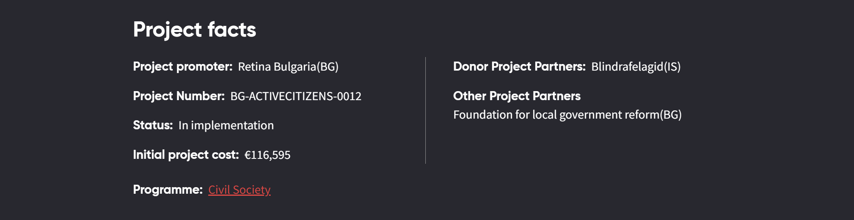

Tips:
Reiterate the main point
Answer potential questions you’re raised
Send readers elsewhere
Issue a challenge
Point to the future
Make a new connection
Length: ideally 2 or 3 sentences with links.

